- The graph of g consists of two straight lines and a semi-circle. Use it to evaluate each integral.

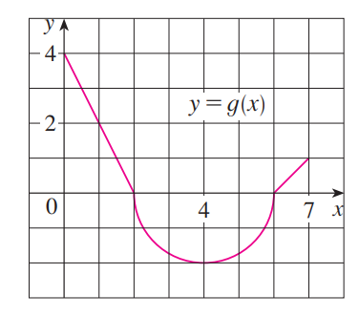

- Suppose that are continuous functions at all real numbers and that
Use properties of integrals to compute each of the following.

- Which of the following is true? How can you fully justify your answer without the use of a calculator?
- OR B.

- Computing the integral is very difficult to do. Using properties of integrals to determine lower and upper bounds on the value of this integral.

- Suppose that is a continuous function and the average value of on is (where a is some non-zero real number).
- Show that the area between and the x-axis on this same interval is .
- If we know that determine a non-zero value of a such that .
- Show that the function must have a root on the interval .

